Name :MUHAMMAD FAROOQ 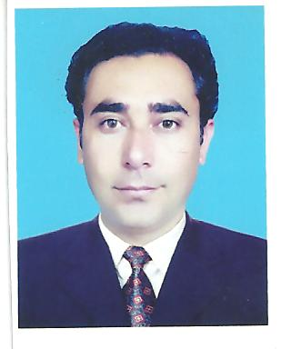

Personal | F/Name: Muhammad Zarin  Gender: Male  Place of Birth: Mardan, Khyber Pakhtunkhwa  Date of Birth: February 04, 1984.  Marital status: Married  Nationality : Pakistani  Languages: English (Fluent), Urdu (advanced), Pashto (Native)  Current Address: Department of Statistics, University of Peshawar.  Permanent Address: Village & P/O Hathian, Tehsil: Takht Bhai District: Mardan, Khyber Pakhtunkhwa, Pakistan  E-mail: m.farooq@uop.edu.pk  mfarooq.uom@gmail.com  Cell : +923339500475
Education | Institutions
M.Phil | University of Peshawar, Department of Statistics, Khyber Pakhtunkhwa, Pakistan.  Performance: (1st Division, CGPA 3.1/4)  Topic: Naïve Bayes approach for the classification of thalessemia patients
M.Sc (Statistics)  2005-2006 | University of Peshawar, Department of Statistics, Khyber Pakhtunkhwa, Pakistan.  Performance: (1st Division, Marks 868/1200)  Major courses: Probability, Sampling, Econometrics, Experimental Design, Statistical Inference etc.
B.Sc  2003-04 | Islamia College Peshawar  Performance: (1st Division, Marks 349/550), Major courses: Maths (A), Maths(B), Statistics
Intermediate  2001-02 | Islamia College Peshawar  . Performance: (1st Division, Marks 750/1100), Major courses: Economics, Statistics, Mathematics
SSC (Humanities)  2000 | Government Higher Secondary School Hathian, Mardan, Pakistan. Performance: (1st Division, Marks 617/850) , Major courses: Mathematics, Physics, Chemistry etc.
Job Experience | Lecturer (BPS-18) in Department of Statistics, University of Peshawar from 1st November 2011 to 20th February 2012 and lecturer in the department of Statistics University of Malakand from 20th Feb 2012 to 4 October 2016, lecturer in the department of Statistics University of Peshawar Since 5th October 2016 to Date.
Honor and awards | Nill
Service Activity | - BS and Master Coordinator in the department UoM.  - Served as Staff Proctor, University of Malakand.  - Serving as an assistant Coordinator in department of Statistics University of Peshawar (UoP)
Research Interest | - Biostatistics.

